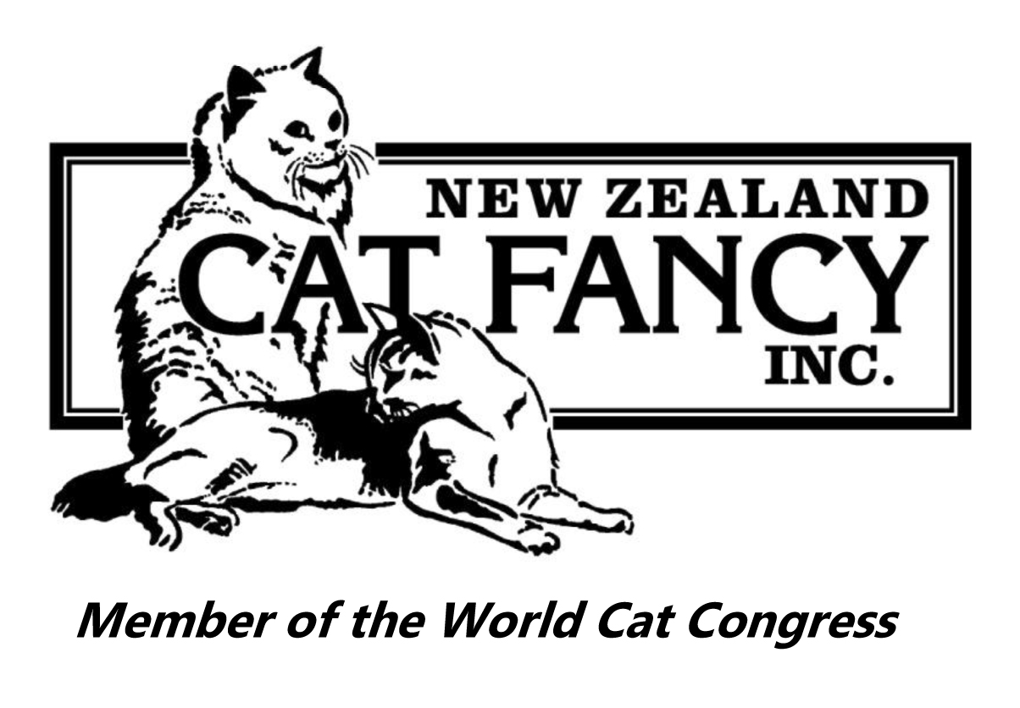
NEW ZEALAND CAT FANCY INC.

Top Ten Results
Show: Abyssinian & Somali Cat Club Inc Date: 14 August 2021
Shorthair Division
Ring No.
1
Judge: John Smithson
Entire Cats
Number of Cats in Ring: 12
Place | Cage No. | Pedigree Name | Breed
BIS | 2 | ODAKIM GARBO'S STAND OUT STYLE | Oriental Shorthair
2nd | 1 | ZOEL ZENSATIONAL | Oriental Shorthair
3rd | 9 | CAIROCATS ODIN RISING | Abyssinian
4th | 11 | FUZZOFF DROPS OF JUPITER | Sphynx
5th | 5 | PAWSABLE PURRPLE REIGN | British Shorthair
6th | 3 | PAWSABLE BACK IN BLACK | British Shorthair
7th | 4 | PAWSABLE LIL BLUE CLAWDETTE | British Shorthair
8th | 6 | FOLDALOTS LIGHT MY WAY | British Shorthair
9th | 8 | MOONSHADOWS TREASURED TIME | British Shorthair
10th | 12 | PAW-FECT LEE FUZZED OFF | Sphynx
BAM | 5 | PAWSABLE PURRPLE REIGN | British Shorthair

Entire Kittens
Number of Kittens in Ring: 13
Place | Cage No. | Pedigree Name | Breed
BIS | 18 | TOBORMORY MR MAHOGANY | Burmese
2nd | 16 | ANKOBER ODETTE | British Shorthair
3rd | 25 | THRUMUSKAYT HEART OF IRON | Cymric
4th | 24 | CHERJON DIEGO | Burmilla
5th | 20 | TOBORMORY SHOUTING WON'T HELP | Burmese
6th | 14 | ODAKIM ASIFBI MAGIC | Javanese
7th | 15 | PAWSABLE STERLNG ROSE | British Shorthair
8th | 22 | TOBORMORY MR SMOOTHTOES | Burmese
9th | 17 | WILDVALLEY AHI | Abyssinian
10th | 21 | TOBORMORY GALWAY GIRL | Burmese
BAM | 25 | THRUMUSKAYT HEART OF IRON | Cymric

Neuter/Spay Cats
Number of Cats in Ring: 11
Place | Cage No. | Pedigree Name | Breed
BIS | 48 | SUNSET POINT ME OUT | Cornish Rex
2nd | 49 | FUZZOFF BLUE BOY YOU | Sphynx
3rd | 41 | SLIQUE RAZZLE DAZZLE | Oriental Shorthair
4th | 44A | PETALS WATSONIA TRUE BLUE | British Shorthair
5th | 46 | KORUCATS GOLDEN KING | Toyger
6th | 45 | BESHA TRUE BLUE | Abyssinian
7th | 44 | PAWSABLE BOHEMIAN RHAPSODY | British Shorthair
8th | 48A | SUNSET GREEDO | Cornish Rex
9th | 42 | ZARZUELA PACIFICA AMOUR | Oriental Shorthair
10th | 43 | ZARZUELA LEFT TURN AT MID NITE | Oriental Shorthair
BAM | 48 | SUNSET POINT ME OUT | Cornish Rex

Neuter/Spay Kittens
Number of Kittens in Ring: 3
Place | Cage No. | Pedigree Name | Breed
BIS | 52 | SHAN LING MR BLUE | Abyssinian
2nd | 51 | ZARZUELA BE MINE TONIGHT | Oriental Shorthair
3rd | 53 | HAVTAHAVIT JANGO FETT | Devon Rex
BAM | 52 | SHAN LING MR BLUE | Abyssinian
Companion Division
Shorthair Companions
Number of SH Companions in Ring: 7
Place | Cage No. | Name
BIS | 65 | LUNA
2nd | 68 | TWIGLET
3rd | 71 | CHOCKY
4th | 69 | CHANDLER
5th | 67 | SHADOW
6th | 70 | TWITCH
7th | 66 | SPARKLE
Domestic Division
Longhair Domestics
Number of LH Domestics in Ring: 1
Place | Cage No. | Name
BIS | 61 | ZACHARIAH

Shorthair Domestics
Number of SH Domestics in Ring: 2
Place | Cage No. | Name
BIS | 63 | DONUT
2nd | 62 | SMITH

Shorthair Division
Ring No.
2
Judge: Ann Skilling
Entire Cats
Number of Cats in Ring: 12
Place | Cage No. | Pedigree Name | Breed
BIS | 9 | CAIROCATS ODIN RISING | Abyssinian
2nd | 2 | ODAKIM GARBO'S STAND OUT STYLE | Oriental Shorthair
3rd | 1 | ZOEL ZENSATIONAL | Oriental Shorthair
4th | 4 | PAWSABLE LIL BLUE CLAWDETTE | British Shorthair
5th | 5 | PAWSABLE PURRPLE REIGN | British Shorthair
6th | 11 | FUZZOFF DROPS OF JUPITER | Sphynx
7th | 10 | ELVES ANEKSI | Abyssinian
8th | 12 | PAW-FECT LEE FUZZED OFF | Sphynx
9th | 3 | PAWSABLE BACK IN BLACK | British Shorthair
10th | 6 | FOLDALOTS LIGHT MY WAY | British Shorthair
BAM | 9 | CAIROCATS ODIN RISING | Abyssinian

Entire Kittens
Number of Kittens in Ring: 13
Place | Cage No. | Pedigree Name | Breed
BIS | 24 | CHERJON DIEGO | Burmilla
2nd | 25 | THRUMUSKAYT HEART OF IRON | Cymric
3rd | 16 | ANKOBER ODETTE | British Shorthair
4th | 18 | TOBORMORY MR MAHOGANY | Burmese
5th | 17 | WILDVALLEY AHI | Abyssinian
6th | 20 | TOBORMORY SHOUTING WON'T HELP | Burmese
7th | 27 | RAREGEMS SHELLY | Sphynx
8th | 14 | ODAKIM ASIFBI MAGIC | Javanese
9th | 15 | PAWSABLE STERLNG ROSE | British Shorthair
10th | 23 | TOBORMORY BONNIE WEE LASS | Burmese
BAM | 25 | THRUMUSKAYT HEART OF IRON | Cymric

Neuter/Spay Cats
Number of Cats in Ring: 11
Place | Cage No. | Pedigree Name | Breed
BIS | 41 | SLIQUE RAZZLE DAZZLE | Oriental Shorthair
2nd | 44A | PETALS WATSONIA TRUE BLUE | British Shorthair
3rd | 46 | KORUCATS GOLDEN KING | Toyger
4th | 42 | ZARZUELA PACIFICA AMOUR | Oriental Shorthair
5th | 43 | ZARZUELA LEFT TURN AT MID NITE | Oriental Shorthair
6th | 45 | BESHA TRUE BLUE | Abyssinian
7th | 48A | SUNSET GREEDO | Cornish Rex
8th | 49 | FUZZOFF BLUE BOY YOU | Sphynx
9th | 48 | SUNSET POINT ME OUT | Cornish Rex
10th | 47 | KORUCATS FOREVA MY LOVE | Toyger
BAM | 46 | KORUCATS GOLDEN KING | Toyger

Neuter/Spay Kittens
Number of Kittens in Ring: 3
Place | Cage No. | Pedigree Name | Breed
BIS | 51 | ZARZUELA BE MINE TONIGHT | Oriental Shorthair
2nd | 53 | HAVTAHAVIT JANGO FETT | Devon Rex
3rd | 52 | SHAN LING MR BLUE | Abyssinian
BAM | 53 | HAVTAHAVIT JANGO FETT | Devon Rex
Companion Division
Shorthair Companions
Number of SH Companions in Ring: 7
Place | Cage No. | Name
BIS | 69 | CHANDLER
2nd | 68 | TWIGLET
3rd | 65 | LUNA
4th | 66 | SPARKLE
5th | 71 | CHOCKY
6th | 70 | TWITCH
7th | 67 | SHADOW
Domestic Division
Longhair Domestics
Number of LH Domestics in Ring: 1
Place | Cage No. | Name
BIS | 61 | ZACHARIAH

Shorthair Domestics
Number of SH Domestics in Ring: 2
Place | Cage No. | Name
BIS | 63 | DONUT
2nd | 62 | SMITH

Shorthair Division
Ring No.
3
Judge: David Colley
Entire Cats
Number of Cats in Ring: 12
Place | Cage No. | Pedigree Name | Breed
BIS | 6 | FOLDALOTS LIGHT MY WAY | British Shorthair
2nd | 11 | FUZZOFF DROPS OF JUPITER | Sphynx
3rd | 9 | CAIROCATS ODIN RISING | Abyssinian
4th | 2 | ODAKIM GARBO'S STAND OUT STYLE | Oriental Shorthair
5th | 10 | ELVES ANEKSI | Abyssinian
6th | 5 | PAWSABLE PURRPLE REIGN | British Shorthair
7th | 12 | PAW-FECT LEE FUZZED OFF | Sphynx
8th | 7 | FOLDALOTS NOTHING COMPARES | British Shorthair
9th | 4 | PAWSABLE LIL BLUE CLAWDETTE | British Shorthair
10th | 3 | PAWSABLE BACK IN BLACK | British Shorthair
BAM | 6 | FOLDALOTS LIGHT MY WAY | British Shorthair

Entire Kittens
Number of Kittens in Ring: 13
Place | Cage No. | Pedigree Name | Breed
BIS | 18 | TOBORMORY MR MAHOGANY | Burmese
2nd | 16 | ANKOBER ODETTE | Abyssinian
3rd | 25 | THRUMUSKAYT HEART OF IRON | Cymric
4th | 24 | CHERJON DIEGO | Burmilla
5th | 15 | PAWSABLE STERLNG ROSE | British Shorthair
6th | 17 | WILDVALLEY AHI | Abyssinian
7th | 27 | RAREGEMS SHELLY | Sphynx
8th | 20 | TOBORMORY SHOUTING WON'T HELP | Burmese
9th | 21 | TOBORMORY GALWAY GIRL | Burmese
10th | 14 | ODAKIM ASIFBI MAGIC | Javanese
BAM | 25 | THRUMUSKAYT HEART OF IRON | Cymric

Neuter/Spay Cats
Number of Cats in Ring: 11
Place | Cage No. | Pedigree Name | Breed
BIS | 41 | SLIQUE RAZZLE DAZZLE | Oriental Shorthair
2nd | 48 | SUNSET POINT ME OUT | Cornish Rex
3rd | 44A | PETALS WATSONIA TRUE BLUE | British Shorthair
4th | 46 | KORUCATS GOLDEN KING | Toyger
5th | 49 | FUZZOFF BLUE BOY YOU | Sphynx
6th | 47 | KORUCATS FOREVA MY LOVE | Toyger
7th | 45 | BESHA TRUE BLUE | Abyssinian
8th | 42 | ZARZUELA PACIFICA AMOUR | Oriental Shorthair
9th | 48A | SUNSET GREEDO | Cornish Rex
10th | 44 | PAWSABLE BOHEMIAN RHAPSODY | British Shorthair
BAM | 44A | PETALS WATSONIA TRUE BLUE | British Shorthair

Neuter/Spay Kittens
Number of Kittens in Ring: 3
Place | Cage No. | Pedigree Name | Breed
BIS | 52 | SHAN LING MR BLUE | Abyssinian
2nd | 51 | ZARZUELA BE MINE TONIGHT | Oriental Shorthair
3rd | 53 | HAVTAHAVIT JANGO FETT | Devon Rex
BAM | 52 | SHAN LING MR BLUE | Abyssinian

Companion Division
Shorthair Companions
Number of SH Companions in Ring: 7
Place | Cage No. | Name
BIS | 68 | TWIGLET
2nd | 70 | TWITCH
3rd | 65 | LUNA
4th | 71 | CHOCKY
5th | 69 | CHANDLER
6th | 67 | SHADOW
7th | 66 | SPARKLE
Domestic Division
Longhair Domestics
Number of LH Domestics in Ring: 1
Place | Cage No. | Name
BIS | 61 | ZACHARIAH

Shorthair Domestics
Number of SH Domestics in Ring: 2
Place | Cage No. | Name
BIS | 63 | DONUT
2nd | 62 | SMITH

